|  |  |
| --- | --- |
| **Experiment # 2** | |
| **Date of Performance:- 05/01 /2023** | **Date of Submission:- 05 /01/2023** |
| **Student SAP Id:- 70362019327** | |
| **Student Roll No:- E009** | |
| **Student Name:- Dhrumil Burad** | |

**Aim: - Design following –webpages using HTML…**

Create a static web page using HTML

1. Create one HTML to interlink the webpages created in expt#1, use attributes link, alink and vlink for text hyperlinks.
2. Make use target attribute for the link (use values: self, blank)
3. Create link to section within same page (of your CV implemented in expt#1)
4. Use attribute type for lists in program 1 to change the type of sequence numbering & different symbols for unordered list.
5. Registration page (**Now, implement it using form tag**)
6. One web page with frames implemented (to display all three web pages implemented in expt #1) column-wise

**Note:- Don’t use any type of CSS in your code…**

**HTML Code 1 and 2 : -**

* **Code of interlink & target attribute**
* <body link="green" alink="yellow" vlink="red">
* <br>
* <br>
* <p align="center" id="a"><a href="./prac 2 homepage.html" target="_blank">MY CV</a><a> &nbsp &nbsp &nbsp </a> <a
* href="./prac 2 regispage.html" target="_parent">Registration
* page</a> <a> &nbsp &nbsp &nbsp </a> <a href="./prac 2 contact.html">Contact us</a>
* </p>
* <br>
* <br>

**Output (only in print screen format) Code -1 & 2**

* **Output**

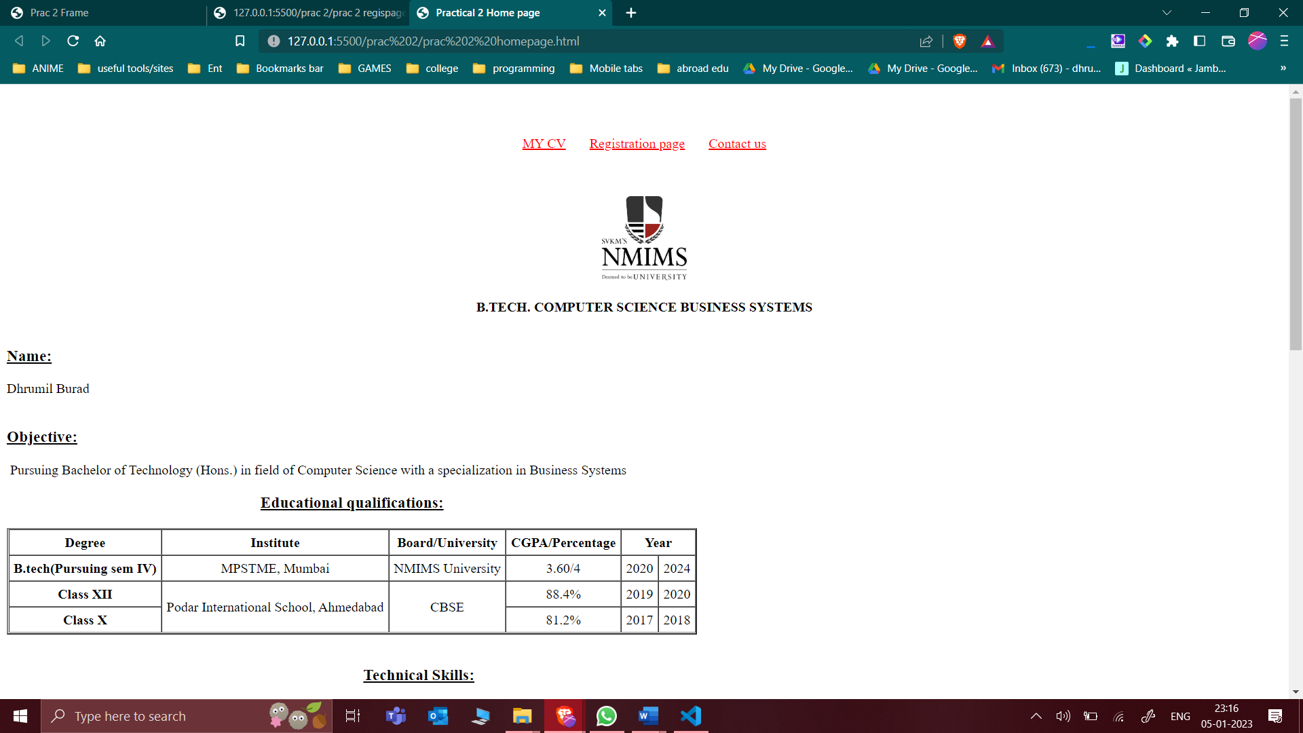

**HTML Code 3 ,4 and 5 : -**

* **Modified code of CV implemented in Expt#1**
* <!DOCTYPE html>
* <html>
* <head>
* <meta charset="utf-8">
* <meta http-equiv="X-UA-Compatible" content="IE=edge">
* <title>Practical 2 Home page</title>
* <meta name="description" content="">
* <meta name="viewport" content="width=device-width, initial-scale=1">
* </head>
* <body link="green" alink="yellow" vlink="red">
* <br>
* <br>
* <p align="center" id="a"><a href="./prac 2 homepage.html" target="_blank">MY CV</a><a> &nbsp &nbsp &nbsp </a> <a
* href="./prac 2 regispage.html" target="_parent">Registration
* page</a> <a> &nbsp &nbsp &nbsp </a> <a href="./prac 2 contact.html">Contact us</a>
* </p>
* <br>
* <br>
* <div align="center" id="logo">
* <img width="100px" src="./nmimslogo.png" alt="Logo">
* <br>
* <br>
* <strong> B.TECH. COMPUTER SCIENCE BUSINESS SYSTEMS</strong>
* <br>
* </div>
* <div>&nbsp&nbsp&nbsp&nbsp<strong>
* <h3> <u> Name:</u> </h3>
* </strong>Dhrumil Burad</div>
* <div>&nbsp&nbsp&nbsp&nbsp<strong>
* <h3 width="30px"> <u>Objective:</u> </h3>
* </strong> &nbspPursuing Bachelor of Technology (Hons.) in field of
* Computer Science with a specialization in Business Systems
* </div>
* <table border="2px" cellspacing="0" cellpadding="5px">
* <caption>
* <h3><u>Educational qualifications:</u></h3>
* </caption>
* <tr align="center">
* <th>Degree</th>
* <th>Institute</th>
* <th>Board/University</th>
* <th>CGPA/Percentage</th>
* <th colspan="2">Year</th>
* </tr>
* <tr align="center">
* <th>B.tech(Pursuing sem IV)</th>
* <td>MPSTME, Mumbai</td>
* <td>NMIMS University</td>
* <td>3.60/4</td>
* <td>2020</td>
* <td>2024</td>
* </tr>
* <tr align="center">
* <th>Class XII</th>
* <td rowspan="2">Podar International School, Ahmedabad</td>
* <td rowspan="2">CBSE</td>
* <td>88.4%</td>
* <td>2019</td>
* <td>2020</td>
* </tr>
* <tr align="center">
* <th>Class X</th>
* <td>81.2%</td>
* <td>2017</td>
* <td>2018</td>
* </tr>
* </table>
* <br>
* <table border="2px" cellspacing="0" cellpadding="5px">
* <caption>
* <h3><u>Technical Skills:</u></h3>
* </caption>
* <tr>
* <th>Domain</th>
* <th>Proficient in</th>
* <th>Familiar with</th>
* </tr>
* <tr>
* <th>Languages</th>
* <td>C++, HTML, CSS</td>
* <td>C, Java, Python,JavaScript</td>
* </tr>
* <tr>
* <th>Libraries and Frameworks</th>
* <td>Pandas, Numpy, Matplotlib</td>
* <td>Sklearn, seaborn</td>
* </tr>
* <tr>
* <th>Software</th>
* <td>Visual Studio Code, Code Blocks, NetBeans 8.0, <br>
* Adobe Illustrator, Canva, OBS studio, Camtasia, Jupyter<br>
* Notebooks, power director, FilmoraGo, Microsoft word,
* <br> Microsoft PowerPoint, Turbo C++, JFLAP, Pycharm
* </td>
* <td>Adobe Photoshop, Blender, TASM, <br>
* Star UML, Anaconda navigator, Microsoft Excel</td>
* </tr>
* <tr>
* <th>Concepts</th>
* <td>Business communication and value sciences,
* <br>Software engineering, Software Design UML
* </td>
* <td>Object Oriented Programming, Front end Web development<br>
* Data structures and algorithms</td>
* </tr>
* </table>
* <br>
* <table border="2px" cellspacing="0" cellpadding="5px">
* <caption>
* <h3><u>Key projects:</h3></u>
* </caption>
* <tr>
* <th>YEAR</th>
* <th>Project Title</th>
* <th>Software/ Tools/ Platforms</th>
* <th>Brief Description</th>
* </tr>
* <tr>
* <td>2021</td>
* <td>Online Shopping System</td>
* <td>Repl.it</td>
* <td>A group project wherein we made an online shopping system on repl.it using concepts of C++ and file
* handling.<br> It was a menu driven program where administrator had the options to update the item
* database and user <br>had options to view items, Add items to cart, view cart and payment</td>
* </tr>
* <tr>
* <td>2021</td>
* <td>The Streaming platform</td>
* <td>Visual studio code, Brave browser, Code Blocks</td>
* <td>In this project we made a dummy streaming platform using HTML, CSS and C++. The user could register or
* login <br>to the platform and then had options to choose a subscription and make payment. A SRS was made
* for the whole <br>project according to which code was implemented</td>
* </tr>
* <tr>
* <td>2022</td>
* <td>Multifunctional Pose Estimator Workout Guider </td>
* <td>Jupyter, Python, Collab,</td>
* <td>Developed a multifunctional pose estimator as a workout guide to track exercise repetitions. It uses
* human pose<br> estimation to track users' bodily motions. This, in turn, maintains track of exercise
* repetitions and detects incorrect <br>body positions while performing the exercise and also suggests how
* you should correct the form.</td>
* </tr>
* </table>
* <br>
* <h3><u>TECHNICAL -PRESENTATION/WORKSHOPS/CERTIFICATION</u></h3>
* <ol style="list-style-type:upper-alpha;"">
* <li> JavaScript, NodeJS and ReactJS, Ocufox Technologies in association with MPSTME, July 2022</li>
* <li> HTML Essential Training, LinkedIn Learning, May 2022</li>
* <li> Cold Calling: The First Seven Seconds, LinkedIn Learning, May 2022</li>
* <li> Learning to Say No with Confidence and Grace, LinkedIn Learning, January 2022</li>
* <li> edX Verified Certificate for Python Basics for Data Science, IBM, June 2021</li>
* <li> edX Verified Certificate for Preparing to Network in English, UWashingtonX, June 2021</li>
* <li> Udemy: Adobe Illustrator 2021 Ultimate Course, Learn Tech Plus, June 2021</li>
* </ol>
* <br>
* <h3><u>TECHNICAL -WORK EXPERIENCE / INTERNSHIPS:</u></h3>
* <ul style=" list-style-type:square;">
* <li>Internshala <a> &nbsp &nbsp &nbsp &nbsp &nbsp &nbsp &nbsp &nbsp &nbsp &nbsp &nbsp &nbsp &nbsp </a> 3 months|
* Feb, 2021 to April, 2021| 2nd Sem
* <br> Student Partner
* </li>
* <li>Henry Harvin <a> &nbsp &nbsp &nbsp &nbsp &nbsp &nbsp &nbsp &nbsp &nbsp &nbsp &nbsp </a> 2
* months| April, 2021 to May, 2021 | 2nd Sem
* <br>Official Skill Ambassador
* </li>
* </ul>
* <button><a href="#a">go to top 👆</a></button>
* </body>
* </html>

**Output (only in print screen format) Code -3 to 5**

* **Output**

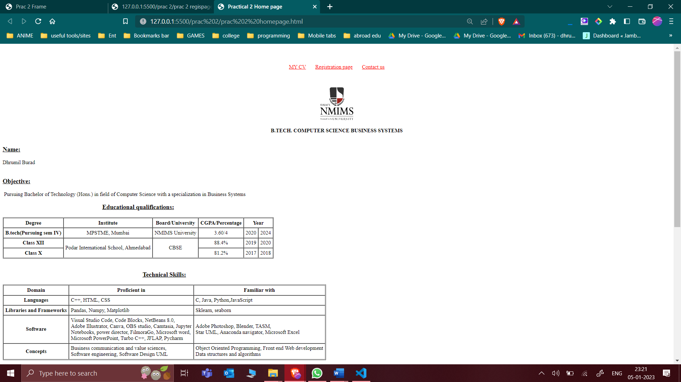

**HTML Code 6 : -**

* **Registration Form**
* <!DOCTYPE html>
* <html>
* <head>
* <meta charset="utf-8">
* <meta http-equiv="X-UA-Compatible" content="IE=edge">
* <title></title>
* <meta name="description" content="">
* <meta name="viewport" content="width=device-width, initial-scale=1">
* <link rel="stylesheet" href="formpractice.css">
* <style>
* datalist {
* display: flex;
* flex-direction: column;
* justify-content: space-evenly;
* writing-mode: vertical-lr;
* width: 120px;
* margin-left: 710px;
* }
* </style>
* </head>
* <body>
* <p align="center" id="a"><a href="./prac 2 homepage.html" target="_blank">MY CV</a><a> &nbsp &nbsp &nbsp </a> <a
* href="./prac 2 regispage.html" target="_parent">Registration
* page</a> <a> &nbsp &nbsp &nbsp </a> <a href="./prac 2 contact.html">Contact us</a>
* </p>
* <br>
* <br>
* <h1 align="center">Registration Form</h1>
* <hr size="2" color="black">
* <form align="center">
* First Name : <input type="text" placeholder="First name" size="20" required autofocus><br><br>
* Last Name : <input type="text" placeholder="Last name"><br><br>
* Email : <input type="email" placeholder="First name"><br><br>
* Password : <input type="password" placeholder="Password"><br><br>
* Confirm passwrod: <input type="password" placeholder="Re-enter Password"><br><br>
* Phone Number : <input type="number" placeholder="Number"><br><br>
* <p>Range of package expected:</p>
* <input type="range" width="850px" list="tickmarks">
* <div>
* <datalist id="tickmarks">
* <option value="25">5LPA</option>
* <option value="50">10LPA</option>
* <option value="75">20LPA</option>
* <option value="100">25+LPA</option>
* </datalist>
* </div>
* <table border="0" align="center" cellpadding="5px">
* <tr align="center">
* <td>Gender:</td>
* <td><input type="radio" name="User_gender" value="m" required>Male<br>
* </td>
* </tr>
* <tr align="center">
* <td></td>
* <td><input type="radio" name="User_gender" value="f">Female</td>
* </td>
* </tr>
* </table>
* *<!-- <br><br> -->*
* Mode of work :
* <input type="checkbox" name="User_mode" value="Online">Online
* <input type="checkbox" name="User_mode" value="Inperson">Inperson
* <input type="checkbox" name="User_mode" value="Hybrid">Hybrid
* <br><br>
* Upload File :
* <input type="file" name="User_file"><br><br>
* Address :
* <BR>
* <textarea cols="30" rows="5" placeholder="First name"></textarea><br><br>
* Transportation : <select name="User_Trans">
* <optgroup label="Two-Wheeler">
* <option value="Bike">Bike</option>
* <option value="motorBike">MotorBike</option>
* </optgroup>
* <optgroup label="Four-Wheeler">
* <option value="Van">Van</option>
* <option value="Car">Car</option>
* <option value="Bus">Bus</option>
* </optgroup>
* </select><br><br>
* <center>
* <button type="submit">Submit Now</button>
* <button type="reset">Reset Now</button>
* </center>
* </form>
* </body>
* </html>

**Output (only in print screen format) Code -6**

* **Output**

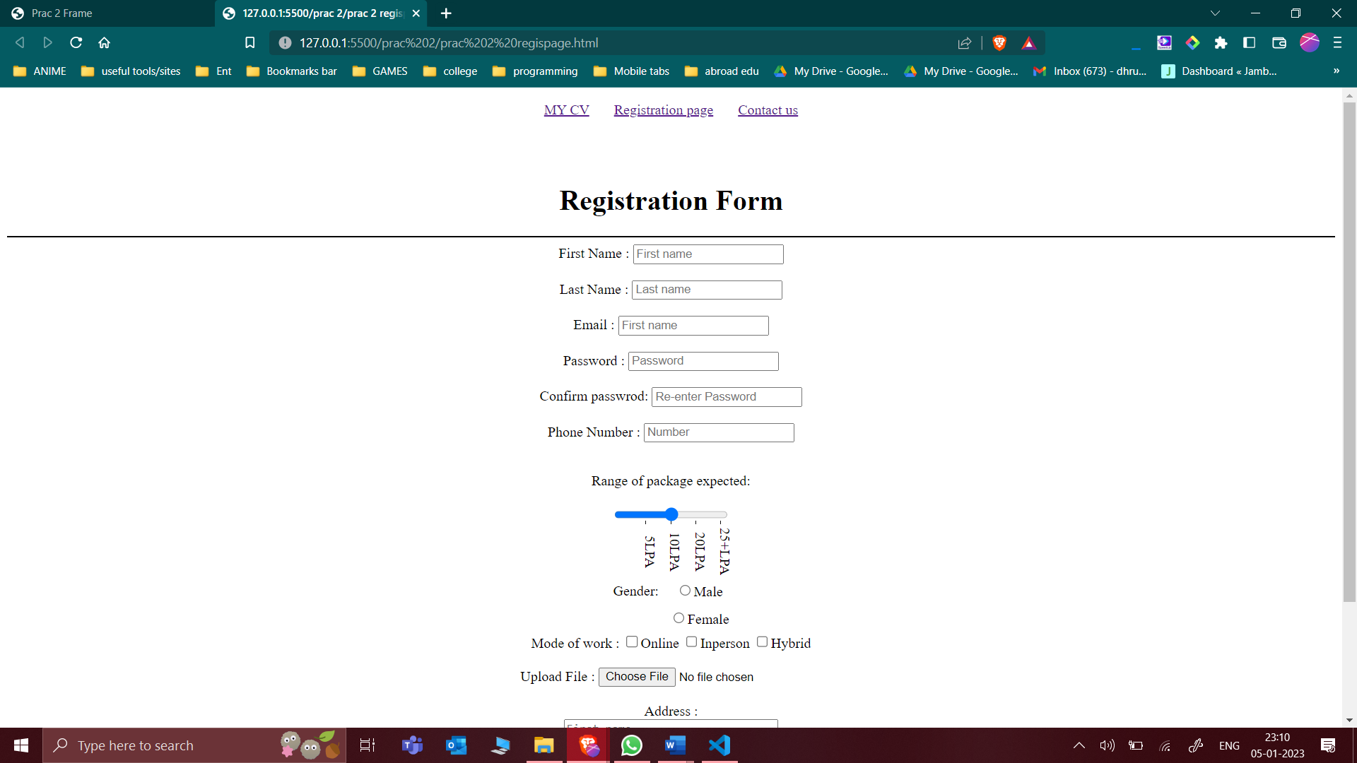

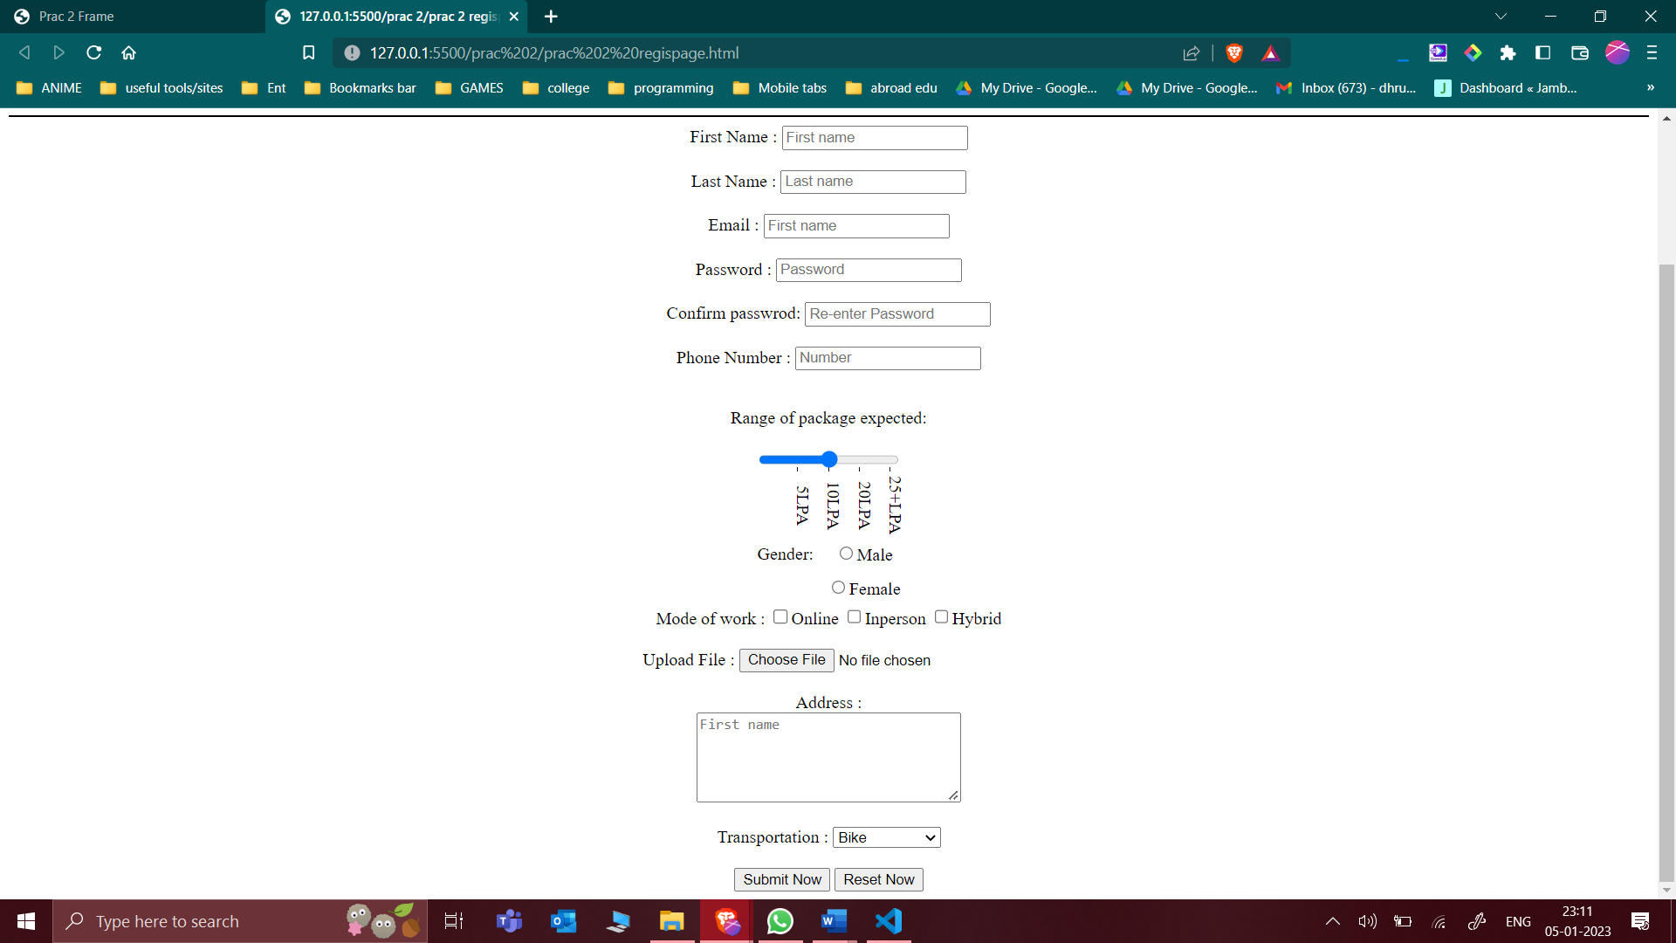

**HTML Code 7 : -**

* **Frame**
* <!DOCTYPE html>
* <html lang="en">
* <head>
* <meta charset="UTF-8">
* <meta http-equiv="X-UA-Compatible" content="IE=edge">
* <meta name="viewport" content="width=\, initial-scale=1.0">
* <title>Prac 2 Frame</title>
* </head>
* <frameset cols="*,*,*">
* <frame src="./prac 2 homepage.html">
* <frame src="./prac 2 regispage.html">
* <frame src="./prac 2 contact.html">
* </frameset>
* </html>

**Output (only in print screen format) Code -7**

* **Frame output**

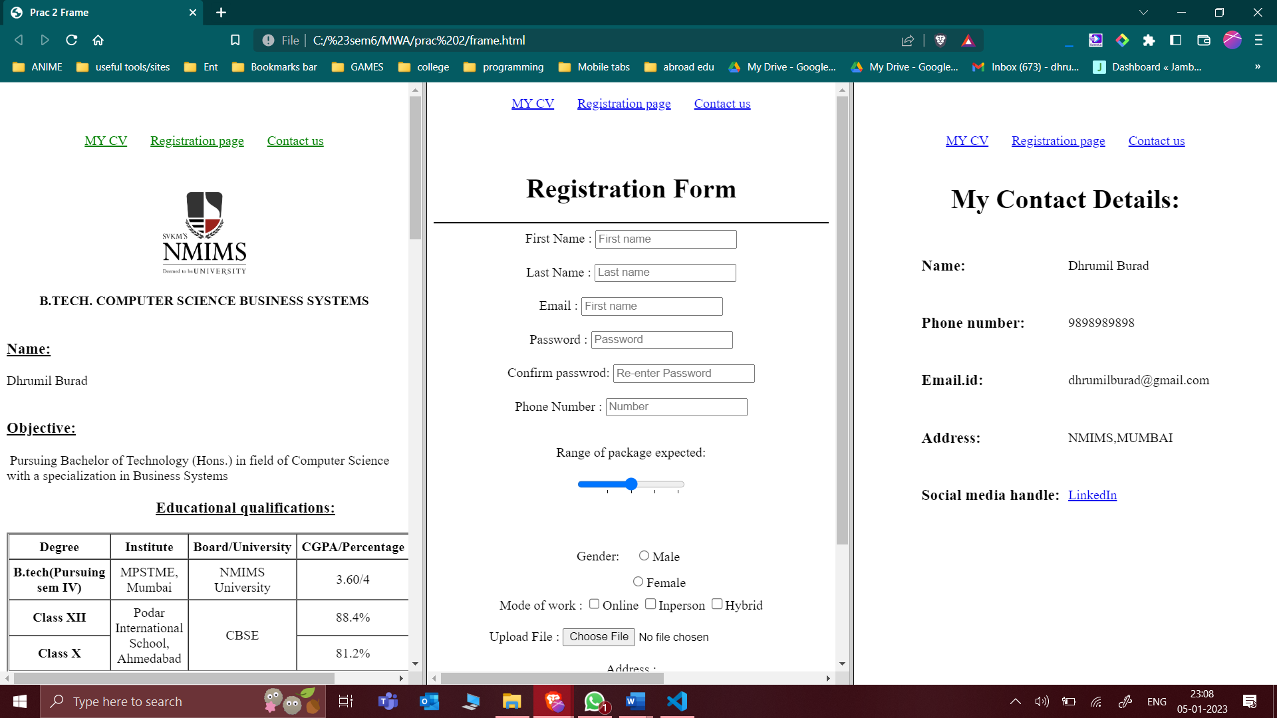

**Observation and Learning: -**

* **Write your observation and learning**

Learnt how to successfully implement attributes link, alink and vlink and use target attribute. Created a link button linking the top section in the same page that redirects to the top of the page on clicking. Learnt how to change the sequence numbering of ordered lists and symbols for the unordered lists. Implemented Registration page using the form tag. Also learnt how to implement the frame tag

**Answer the Questions: -**

1. **What is hyperlink in HTML? Which tag is used? What are various attributes of <a>? explain.**

In HTML, a hyperlink is a reference to another web page or location on the same page. It allows users to click on a word, phrase, or image to jump to a different location within the same document or to a different web page. The anchor tag, <a>, is used to create a hyperlink in HTML.

**Here are some attributes of the <a> tag:**

**href:** This attribute specifies the destination of the hyperlink. It can be a URL for a web page, a location within the same page (using a # followed by the target element's id), or a file path.

**target:** This attribute specifies where to open the linked document. The values _blank, _self, _parent, and _top can be used to specify that the linked document should be opened in a new window, the current frame, the parent frame, or the full window, respectively.

**rel:** This attribute specifies the relationship between the current document and the linked document. Possible values include alternate, author, bookmark, help, license, next, nofollow, noreferrer, prefetch, prev, search, stylesheet.

**type:** This attribute specifies the media type of the linked document.

**hreflang:** This attribute specifies the language of the linked document.

**download:** This attribute specifies that the linked document should be downloaded rather than displayed in the browser.

**ping:** This attribute specifies a list of URLs to be notified when the linked document is visited.

**<a> tag can be used as:** <a href="https://www.abc.com">Website</a>

This creates a hyperlink to the website "https://www.abc.com" with the text "Website" as the anchor text. When the user clicks on "Website", they will be taken to the specified website.

1. **What are various list tags?**

In HTML, there are two types of lists: ordered lists and unordered lists.

An ordered list is a list of items that are numbered. The <ol> element is used to create an ordered list, and each list item is marked with the <li> element.

**For example:**

**<ol>**

**<li>Item 1</li>**

**<li>Item 2</li>**

**<li>Item 3</li>**

**</ol>**

**This will create a numbered list with three items:**

**Item 1**

**Item 2**

**Item 3**

An unordered list is a list of items that are marked with bullet points. The <ul> element is used to create an unordered list, and each list item is marked with the <li> element. For example:

**<ul>**

**<li>Item 1</li>**

**<li>Item 2</li>**

**<li>Item 3</li>**

**</ul>**

**This will create a bullet point list with three items:**

**Item 1**

**Item 2**

**Item 3**

There is also a **<dl>** element for creating definition lists, which consist of a list of terms and their corresponding definitions. Each term is marked with the **<dt>** element, and each definition is marked with the <dd> element. For example:

**<dl>**

**<dt>Term 1</dt>**

**<dd>Definition 1</dd>**

**<dt>Term 2</dt>**

**<dd>Definition 2</dd>**

**</dl>**

This will create a definition list with two terms and definitions:

Term 1

Definition 1

Term 2

Definition 2

1. **What are various table tags?**

**There are several HTML tags that are used to create tables:**

**<table>:** This tag is used to define a table in HTML.

**<tr>:** This tag is used to define a row in an HTML table

**<td>:** This tag is used to define a cell in an HTML table.

**<th>:** This tag is used to define a table header cell in an HTML table.

**<caption>:** This tag is used to define a table caption in an HTML table.

**<thead>:** This tag is used to define the header of an HTML table.

**<tbody>:** This tag is used to define the body of an HTML table.

**<tfoot>:** This tag is used to define the footer of an HTML table.

**<colgroup>:** This tag is used to define a group of columns in an HTML table.

**<col>:** This tag is used to define a column in an HTML table.

You can use these tags to create a variety of tables with different layouts and formatting.

1. **List out various form elements and their associated tags.**

There are several HTML form elements that you can use to create a form on a web page:

**<form>:** This tag is used to define a form in HTML.

**<input>:** This tag is used to create a form input field. There are several types of input fields, including text, password, radio, checkbox, and hidden.

**<textarea>:** This tag is used to create a multi-line text input field.

**<select>:** This tag is used to create a drop-down list of options.

**<option>:** This tag is used to define an option in a drop-down list.

**<button>:** This tag is used to create a button that can be clicked to submit the form or to trigger some other action.

**<label>:** This tag is used to label a form element, such as a text input or a button.

**<fieldset>:** This tag is used to group related form elements together.

**<legend>:** This tag is used to provide a caption for a fieldset.

**<output>:** This tag is used to display the result of a calculation.

You can use these form elements and their associated tags to create a variety of different forms on your web pages.